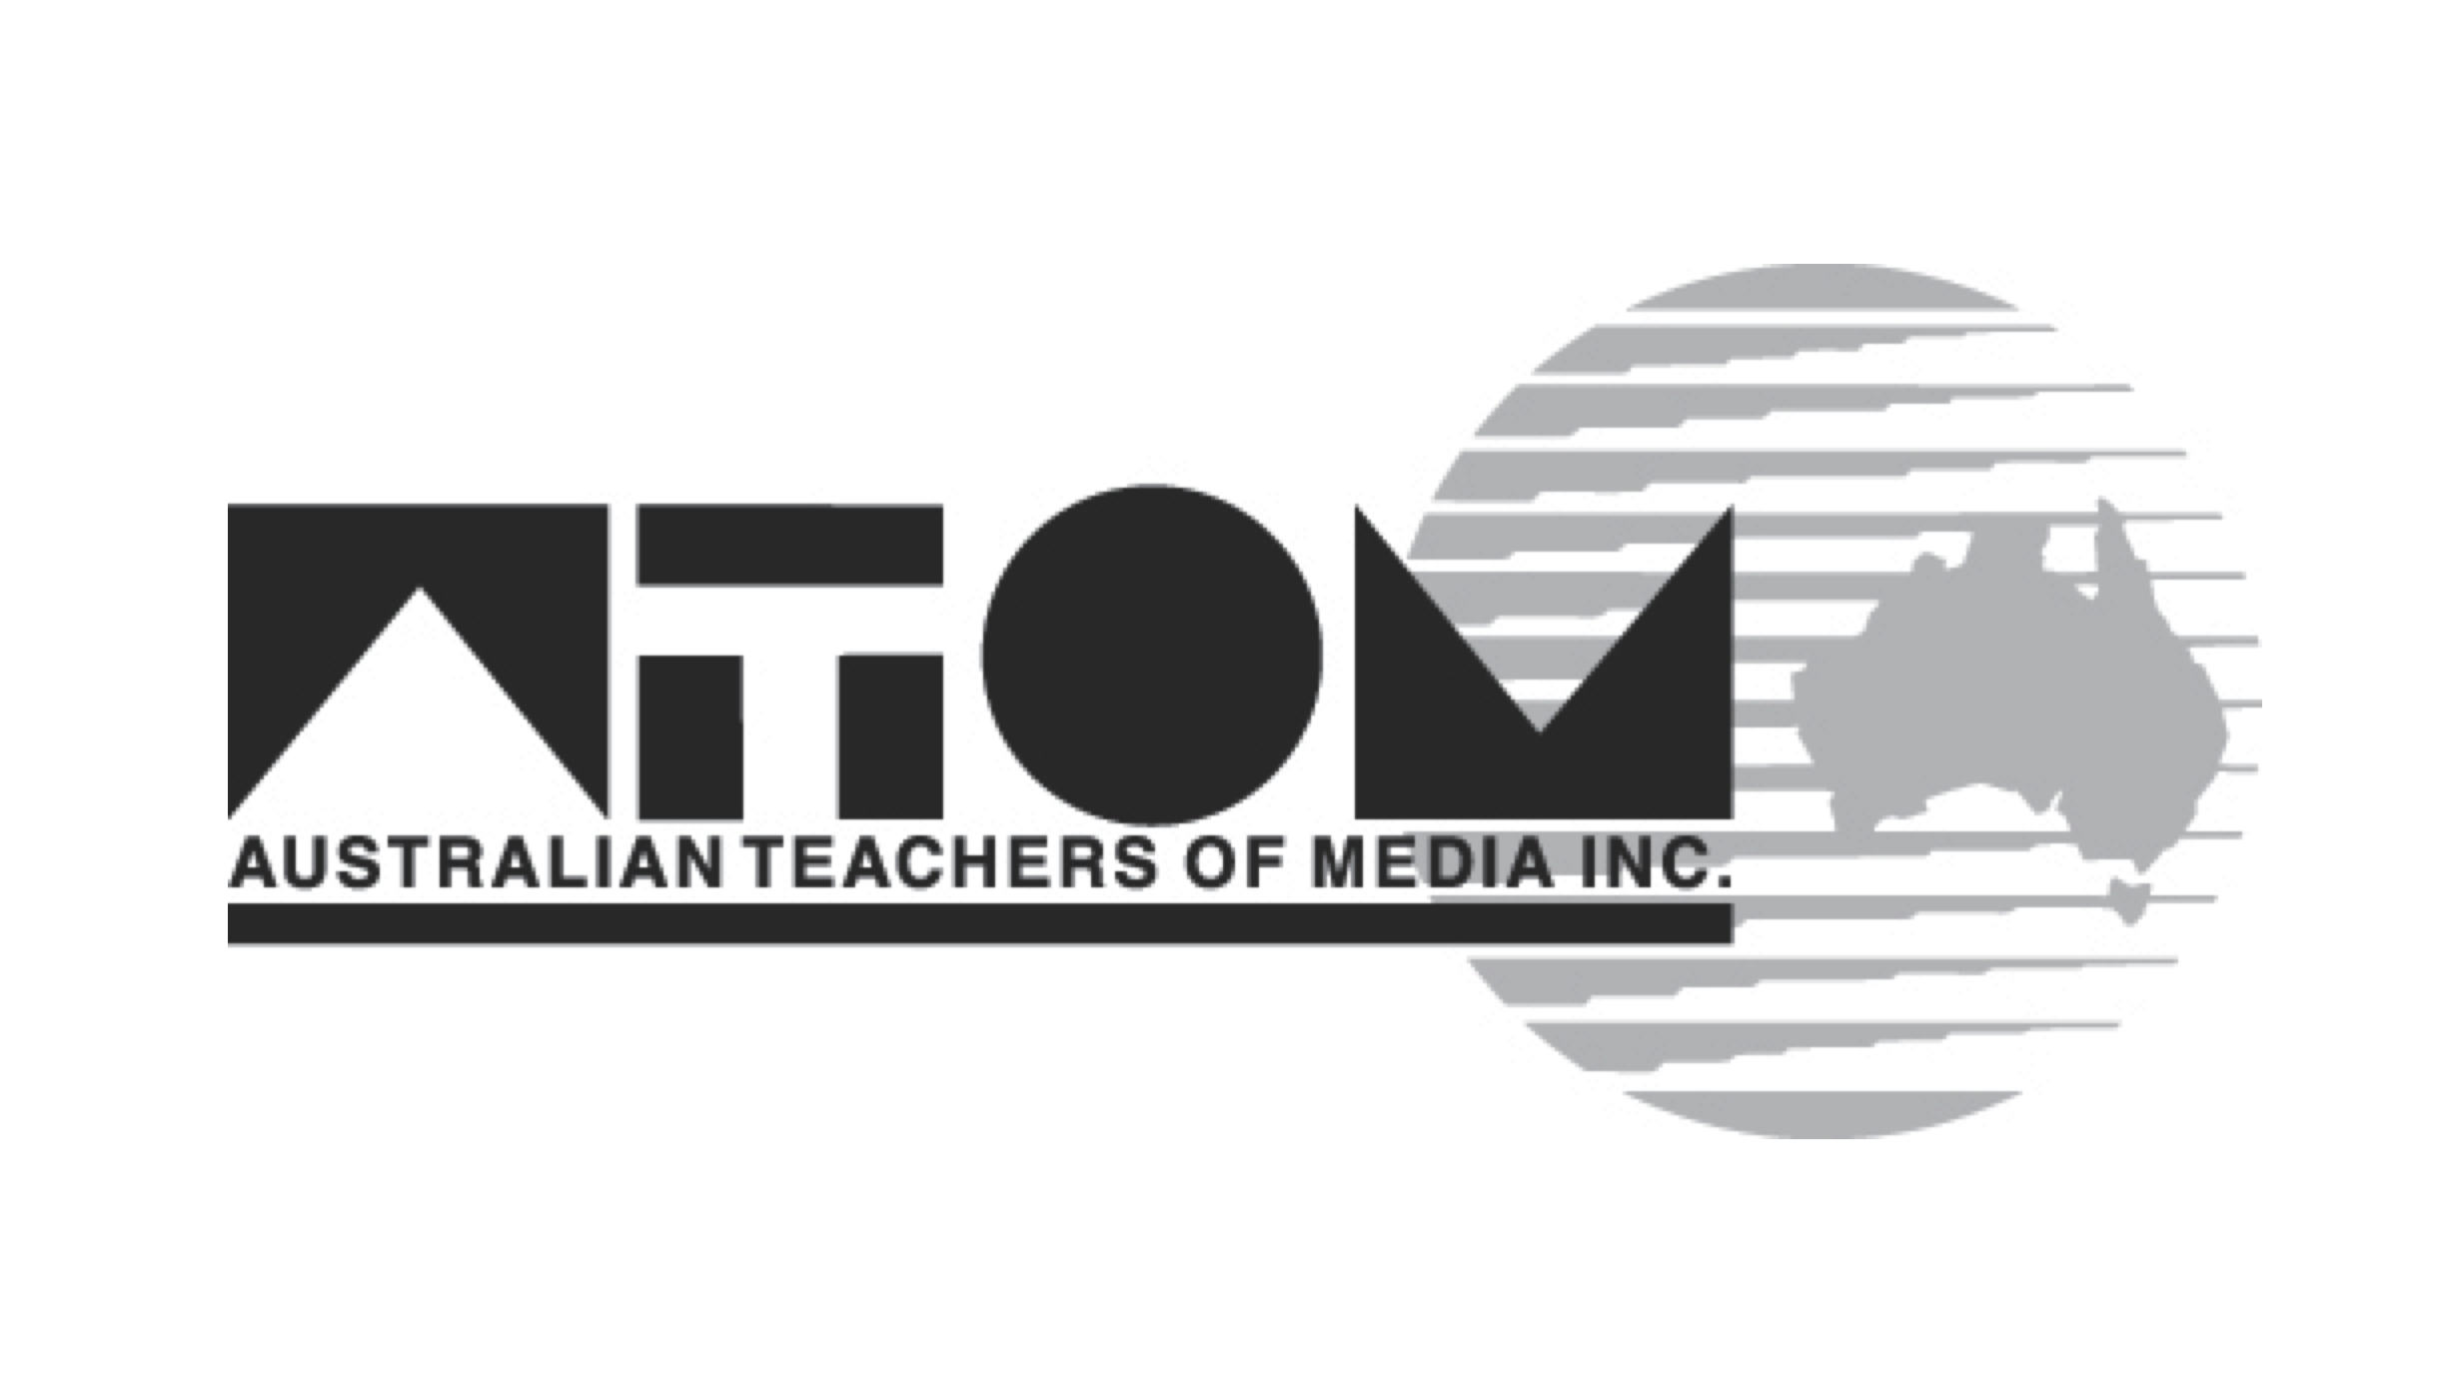

MEDIA
RELEASE

12 November, 2009
SHINING A LIGHT ~
50 YEARS OF THE AUSTRALIAN FILM INSTITUTE

The AFI is where you can “identify the Australian film industry – it is the locus of it – as well as the site of vital discourse.”
Dr George Miller (Happy Feet, Babe: Pig in The City, Mad Max)

A new book, Shining a Light ~ 50 Years of the Australian Film Institute, traces the progress of the film and television industries in Australia – as well as screen culture within Australia over the past half century – through the lens of one key organisation, the Australian Film Institute (AFI).

Since its establishment in 1958, the AFI has played a central role in nurturing and supporting both screen culture and production – from small beginnings to an internationally recognised billion dollar industry.

Shining a Light offers a timely and significant contribution to scholarship on Australian cinema, published at a critical time in Australian film history. The authors, Lisa French and Mark Poole, offer an insider’s view through 27 interviews with key players on the local scene. The book also includes a listing of every AFI Award that has been given since 1958, including the nominees and winners of each award category. This is the first time that such an exhaustive list of AFI nominees and winners has been published.

The authors' collective experience spans filmmaking, academic research and teaching, film journalism, employment and service in key screen culture organisations, as well as an abiding passion for Australian cinema – bringing to this work both the filmmaker and industry perspective, and academic scholarship.

Lisa French is a Associate Professor in Cinema Studies, Media and Communication at RMIT University. She is also the co-author of Womenvision: Women and the Moving Image in Australia and has previously collaborated on film projects with Mark Poole, including making the film Birth of a Film Festival (2003), a film about the first Melbourne International Film Festival. She was a board member of the AFI for nine years and the Director of the St Kilda Film Festival for three years.

Mark Poole is a Melbourne based writer/director and current Victorian Chair of the Australian Writers Guild. He has written more than 20 hours television drama, including the AFI Award winning telefeature A Single Life; he co-produced and directed the documentary Fearless, screened on the ABC (2008); and he is a contributor to the online journal Screen Hub and other publications such as The Age, Metro and Storyline.

The book is published under The Moving Image imprint by the Australian Teachers of Media (ATOM), with support from Film Victoria. The publishing partners are AFI, ACMI, NFSA, RMIT and Victoria Universities. The Moving Image is Australia's
premier book and monograph series for writing on theory, criticism, history, film practice, multimedia, television and photography in Australia.

What: Book launch - Shining a Light ~ 50 Years of the Australian Film Institute
When: Monday 23 November 6pm
Where: ACMI Federation Square, Flinders St, Melbourne.
Website: http://www.metromagazine.com.au/moving_image/index.html
Availability: The book is available exclusively from the AFI until December 15 (see website to download order form http://www.afi.org.au); following this it will be also available from ATOM (also order on their web site http://www.metromagazine.com.au/index.html) and later, in good book stores.

For further information and interviews, contact: Lisa French, Co-author: (03) 9925 3026 or 0407 682 341 & lisa.french@rmit.edu.au or Mark Poole, Co-author 0408 055 478.

